**Investigation to Determine the Presence of OrNV in the Guam CRB population**

**Methods and Materials**

**Sample collection.** Over a 43-day period, coconut rhinoceros beetle (CRB) adults were collected from ChemTica oryctalure baited 40-panel and 31-barrel traps deployed at Leo Palace golf course (central region of Guam) and the Yigo Agricultural Experimental Station (northern region of Guam), respectively (Fig. 1). A total of 100 adults were collected from each location. Each beetle was placed in a new sample jar (pottle) on-site. Data collection included trap barcode number, beetle barcode number, collection date, trap GPS location, and sex. Beetles were maintained in pottles for 24 hours and then washed with the addition of 1 ml nuclease-free water to collect frass material that might contain virus for further analysis.

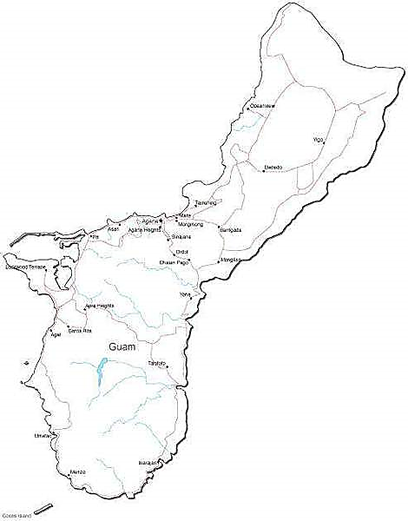  
 Fig. 1

UOG Yigo Agricultural Station (Yigo)

La Palace Resort (Yona)

N

**CRB dissection.** On whole-body dissection, gross visual observation of each individual insect was recorded as to the pathological appearance of its gut (white/thick indicating virus or brown/thin indicating no virus). Prior to gut removal, a photograph was taken of the dissected beetle along with its designated barcode identification. The first 1 cm of adult gut tissue (anterior midgut) was dissected and placed into histology preservation (10% neutral-buffered formalin) for storage at room temperature. For PCR analysis the remaining gut portion (0.5 -1 cm) was placed in 1 ml monopropylene glycol and stored at 4oC. For biotyping to determine if an individual was either CRB-G or CRB-S, 4 legs were removed from the adult and placed in 1 ml monopropylene glycol and stored at 4oC. All samples were shipped to AgResearch Limited in New Zealand to further complete the analysis.

**In-house DNA extraction and PCR.** To determine if virus was present in the frass, extraction of DNA from each 1 ml sample was performed using a viral extraction kit according to the manufacture’s recommendation (BioVision, Inc.). Thermal amplification was performed employing the following conditions according to Marshall et al. (2017) with 15a primer [ATT ACG TCG TAG AGG CAA TC] and 15b primer [CAT GAT CGA TTC GTC TAT GG] and an increase in the annealing cycle of 5: (1) denaturation at 940C for 3 min; (2) 40 cycles of 940C for 30 s, 500C for 45 s, and 720C for 1 min; and (3) a final extension at 720C for 5 min. Illustra PuReTaq™ Ready-to-Go PCR beads in 0.5 µl tubes were used as the PCR reaction mixture, which consists of a 25 µl reaction volume with approximately 2.5 units PuReTaq polymerase, 200 µM dNTP (dATP, dCTP, dGTP, dTTP), BSA, stabilizers and reaction buffer (10 mM Tris-HCl pH 9.0, 50 mM KCl, 1.5 mM MgCl2). DNA in the 1 ml pottle samples quantified by employing a NanoDrop 1000 spectrophotometer varied widely from 2 ng/µl to 85 ng/µl. These measured quantities most likely consisted of virus, if present, along with other extraneous DNA, and so what little viral DNA that was present in the sample was diluted a 1000-fold with nuclease-free water. For PCR the negative control consisted of 1 µl primer and 24 µl nuclease-free water while in the positive control 1 µl primer, 1µl virus template (viral DNA extracted from virus-infected beetle cell culture) and 23 µl nuclease-free water was used for thermal amplification. Field-collected samples consisted of 8 µl DNA template, 1 µl primer, and 16 µl nuclease-free water. All samples were run on a 1.5% Metaphor gel (TBE buffer, pH 8.3) with a Beijing Liuyi DYY-C6 power supply at a constant 120 v, stained with GelGreen and photographed with a BioRad GelDoc XR+ imager. The CRB samples were expected to generated a DNA amplicon sizes of 945 bp.

**Results.** Insect gut and leg samples sent to New Zealand for histological, biotyping, and PCR analysis are still pending. A final total of 195 pottle samples from individual adult CRBs from both L. Palace and Yigo locations analyzed by PCR showed no DNA amplification of an expected 945 bp product, indicating no conclusive evidence for the possible presence of OrNV in the Guam CRB population. However, this is not an all-inclusive analysis of the total Guam CRB population as only two locations were sampled in the survey, and perhaps the presence of OrNV might be detected with further more extensive area-wide sampling.